Lab - 2

Interfacing External LED with Arduino

1. Aim (Objective)
To design a circuit and control an external LED using Arduino digital output.

2. Theory
An LED (Light Emitting Diode) emits light when current flows through it. A resistor is used to limit current and prevent damage.
Ohm’s Law helps determine the required resistor value.
Arduino Uno outputs HIGH (5V) and LOW (0V) signals to control devices.

3. Apparatus / Requirements
- Arduino Uno
- LED
- 220Ω resistor
- Breadboard
- Jumper wires
- Arduino IDE

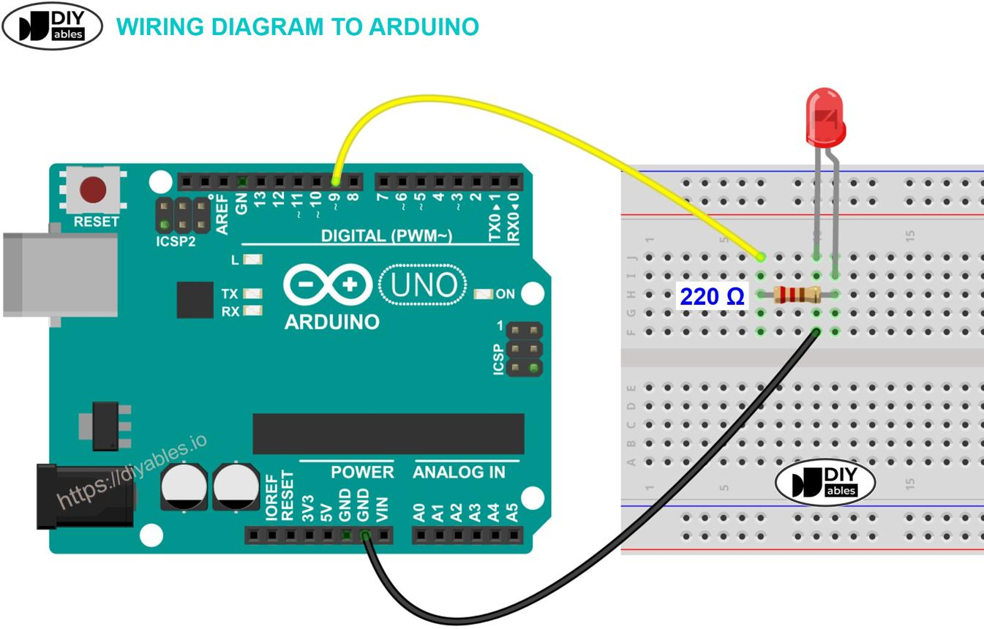
4. Circuit Diagram


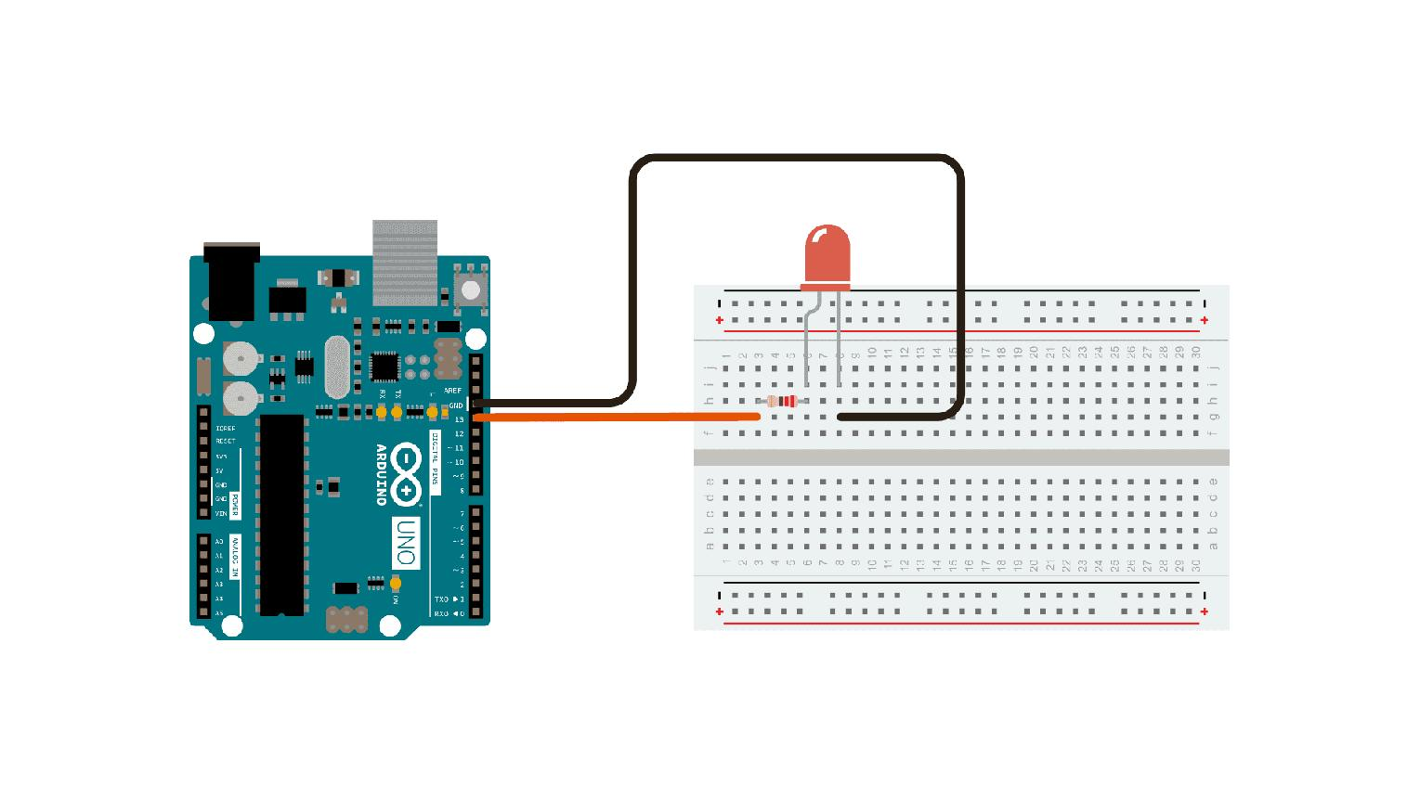

5. Procedure (Steps)
- Place LED on breadboard
- Connect resistor to LED cathode
- Connect resistor to GND
- Connect LED anode to pin 13
- Open Arduino IDE
- Write the program
- Upload code to Arduino
- Observe LED blinking

6. Program / Code
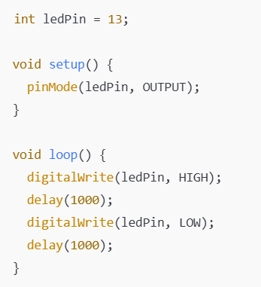

8. Observations / Readings
- LED glows when voltage is HIGH
- LED turns OFF when LOW
- Stable blinking observed
- Proper current limiting ensured by resistor

9. Result
The external LED was successfully interfaced with Arduino and controlled using a digital output signal.

